1. <https://start.spring.io> and add 2 dependencies in API Gateway:
   * 1. Spring Security
     2. OKTA
2. Create a class “security.WebSecurityConfig.java”:

*@Configuration  
@EnableWebSecurity  
@EnableGlobalMethodSecurity*(prePostEnabled = true)  
public class *WebSecurityConfig* {  
  
 *@Bean* public *SecurityFilterChain* securityWebFilterChain(*HttpSecurity http*) throws *Exception* {  
 *http* .authorizeRequests(*authorizeRequest* -> *authorizeRequest*.anyRequest()  
 .authenticated())  
 .oauth2ResourceServer(*OAuth2ResourceServerConfigurer*::jwt);  
  
 return *http*.build();  
 }  
}

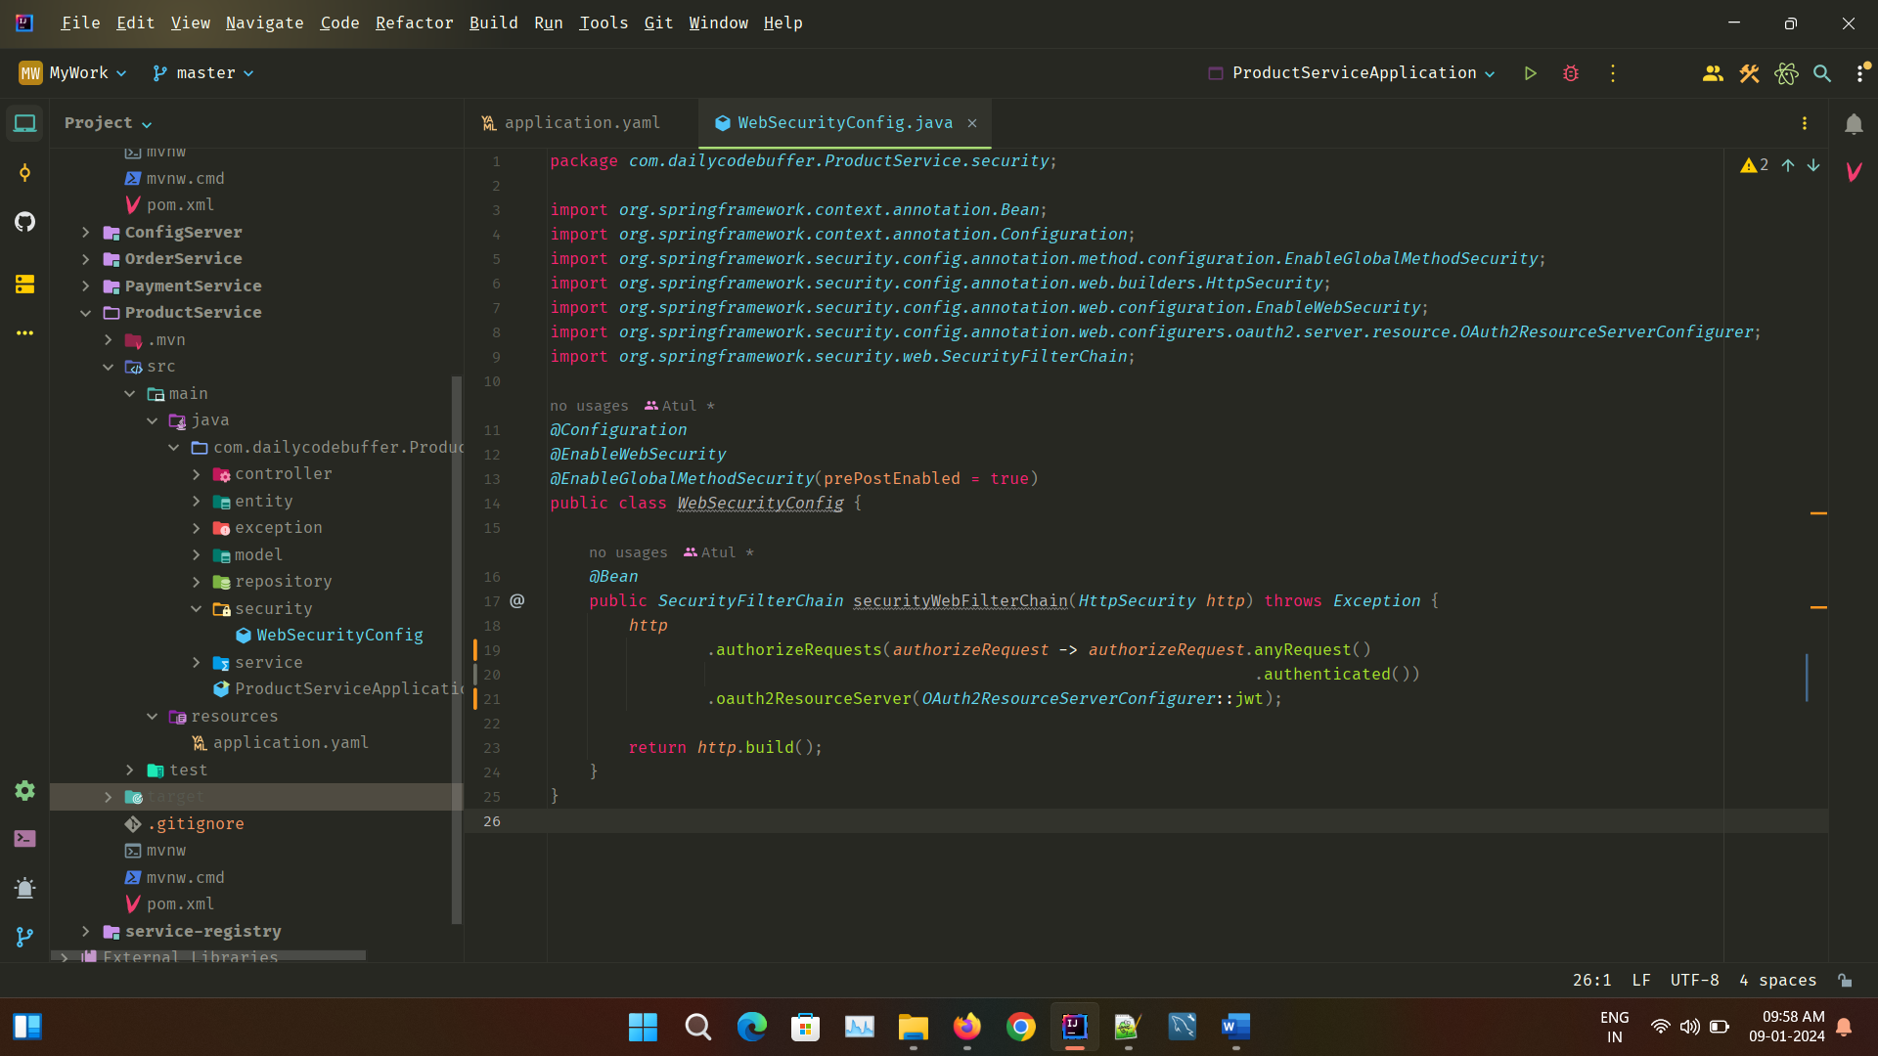

1. Here we are define at method level, come to ProductController level and here for each method we can define what role it has with:  
   @PreAuthorize("hasAuthority('Admin')")  
   @PreAuthorize("hasAuthority('Admin') || hasAuthority('Customer') || hasAuthority('SCOPE_internal')")
2. Open ProductController.java and add these lines.

